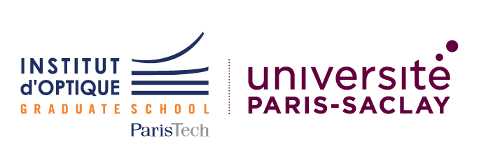
Institut d’Optique Graduate School
Diplôme d’Ingénieur / Master of Science in Engineering
Application For HUST 3+3 Double Degree Students
September 2021 intake

Please complete this form and send by Email with required
documents (see final page) before OCTOBER 30th 2020 to:
pierre.baladi@institutoptique.fr

Supporting documents may also be sent by post to:
Institut d’Optique Graduate School ID picture
Relations Internationales – Pierre Baladi
2, Avenue Augustin Fresnel
91127 PALAISEAU Cedex
France

Personal Information
Family or Last Name |  | First or given name(s)
Date and place of birth |  | Gender (M/F)
Permanent address |  | Temporary address and dates if applicable  (from now until dd/mm/yyyy)
E-mail address for correspondence |  | Telephone number  (e.g. +33-123 45 67 89)

Sending (Home) Institution
Name of Institution | HUST – Huazhong University of Science and Technology
Faculty |  | Department
Address
Contact Person’s name |  | Contact Person’s e-mail and phone

Receiving Institution
Institut d’Optique Graduate School
(Institut d’Optique Théorique et Appliquée)
2 avenue Augustin Fresnel
Fr-91127 PALAISEAU Cedex
France
Contact Person | Pierre BALADI | Contact Person’s  e-mail and phone | pierre.baladi@institutoptique.fr  +33-164 53 32 08

Current year and field of study, with name of the degree programme (e.g. 3rd year student of Engineering Physics in 4 year BSc course)

You are applying to the Master of Science in Engineering – Diplôme d’Ingénieur de l’Institut d’Optique programme as a degree-seeking student under the 3+3 Double Degree Programme between IOGS and HUST.
You will study at IOGS for 3 years (final year of BSc, MSc 1 & MSc 2).

For information:

Regular tuitions fees (per academic year):
- EU citizens: 2 900 euros
- Non-EU citizens: 5 000 euros

Special tuitions fees for 3+3 HUST students (per academic year):
- Same as EU citizens: 2 900 euros

Language skills:
ENGLISH LANGUAGE SKILLS
If English is not your first language, have you studied English?
If YES, give details and duration of study
Do you have an English language qualification (e.g. TOEFL, IELTS, Cambridge Certificates, etc.?)
If YES give name and date of exam and mark obtained (please enclose a copy of the score report)
Personal assessment of your English skills (CEFR - Common European Framework of Reference for Languages). Please tick appropriate box:
 | A1  Beginner | A2 Elementary | B1 Intermediate | B2 Upper Intermediate | C1  Advanced | C2 Proficiency
Reading
Writing
Speaking
Listening
Technical English

What is/are your native language(s)?

FRENCH LANGUAGE SKILLS
If French is not your first language, have you studied French?
If YES, give details and duration of study:
Do you have a French language qualification (e.g. DELF, DALF, TEF, etc.)?
If YES give name and date of exam and mark obtained (please enclose a copy of the score report)
Personal assessment of your French skills (CEFR - Common European Framework of Reference for Languages). Please tick appropriate box:
 | A1  Beginner | A2 Elementary | B1 Intermediate | B2 Upper Intermediate | C1  Advanced | C2 Proficiency
Reading
Writing
Speaking
Listening
Technical French

SUPPORTING DOCUMENTS

LIST OF DOCUMENTS THAT SHOULD BE SENT TO INSTITUT D’OPTIQUE WITH APPLICATION FORM
(please send all supporting documents in one single file, preferably a pdf file)

Required documents:

A letter outlining your motivation for study at Institute d’Optique (4000 signs maximum = approx. one page) within the 3+3 Double-Degree program. In this letter you will include at least:
(i) one paragraph about your motivation for studying abroad,
(ii) and one paragraph about your envisioned future and its relations to optics / photonics / science / industry / academia.

A Curriculum Vitae,

The complete transcripts of your last years of study in higher education (for the current year, attach provisional results, if available); final transcripts/results must be sent as soon as possible,

At least 1 reference letter,

A scanned copy of your ID or Passport (identity photo page)

Additional documents:

Any other document supporting your academic profile (awards, prizes, olympiads…) or test results (language test, GRE…)

